1. Insert a new row into the Facility table with facility name .
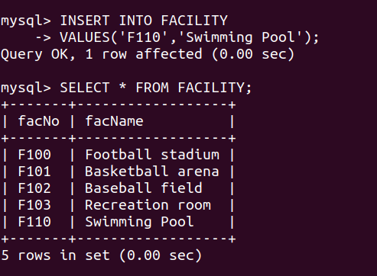

2. Insert a new row in the Location table related to the Facility row in modification problem 1. The new row should have for the location
name.

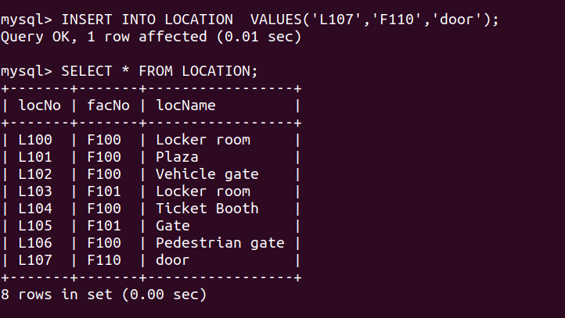

3. Insert a new row in the Location table related to the Facility row in modification problem 1. The new row should have for the location name.
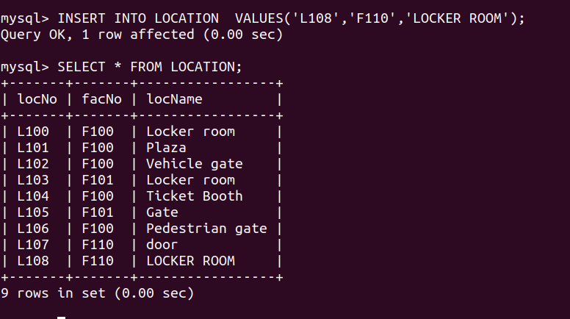

4. Change the location name of to for the row inserted in modification problem 2.

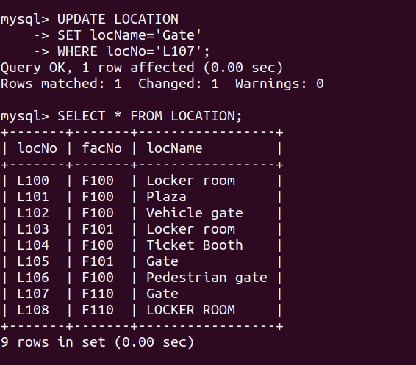

5. Delete the row inserted in modification problem 3.
